CLMC Bulletin 338 – 28.11.17
E Declaration re Whistle Blowing/Freedom to Speak Up
We have had a number of practices contact us with regard to the question on the e-declaration around having a named person for whistle blowing that is not an organisation such as the CCG. Guidance suggests that LMCs may be able to undertake this role which has led to a number of requests. CLMC do not feel we are the best placed – in terms of capacity and our position representing GP – to undertake this role but equally we do not wish to see practices have difficulty due to this question. To this end Dr Julie Birch has kindly agreed to act as the nominated person for practices who are struggling to find an alternative. It is important you contacts CLMC to advise if you are planning to use Julie as you nominated person so we understand numbers and can manage this accordingly.

We have also sought further advice and clarification from NHS E as we do not feel CLMC should be in this position. In response, NHS E has advised that as the question has been phrased “external to the practice”, if a practice has nominated a person employed by the practice then they would need to respond ‘no’. You can then explain your response further by using the free- text field at the end of the declaration to say “Re. Question 5v the practice has identified someone to raise concerns with however they are employed in the practice”. The practice does not need to name the individual.

That said, if you have identified someone internally or externally staff do need to be aware so you will need to include something in your whistleblowing policy so all have access to the name and contact details.

As eluded to earlier, to the ‘freedom to speak up’ guidance suggests the following with regard to a suitable nominated person:

- Arrangement with another local provider;
- Assigned staff role within a larger provider federation/network ;
- Arrangement with the local hospital trust Freedom to Speak Up Guardian;
- Nominated member of the local Clinical Commissioning Group (CCG);
- Nominated member of the Local Professional Network (LPN);
- Nominated member of the Local Representative Committee (LRC);
- Nominated member of the Local Optical Committee (LOC);
- Nominated member of the Local Dental Committee (LDC)
- Regional manager in larger provider organisations;
- Superintendent Pharmacist;
- NHS England Responsible Officers.

NHS E have advised if the issue is with regard to the clinical/professional performance of a GP then the practice could contact the RO at NHS England. If other concerns e.g. Nursing/staff management etc. then there should be other pathways for individuals to use such as those listed above e.g. another local provider. On this basis, it could be most appropriate that policies have a range of people dependent upon the content of the concern being raised.

Clinician Statement, TPP Data Sharing
This statement is an update for GPs on the issue of TPP’s SystmOne and the DPA. As Representatives of the British Medical Association and the Royal College of GPs we have been working closely with NHS England, NHS Digital, TPP and their user group to address our concerns regarding the ability of GP data controllers using SystmOne to comply with the DPA.

We are now at a point where the BMA and RCGP believe that new functionality developed by TPP, when finalised and fully implemented, will allow GP Data Controllers to meet their obligations under the DPA. We expect these tools to be available to all GPs using SystmOne by the end of February 2018.

This new functionality is currently being piloted and we are continuing to monitor progress.

We continue to keep the ICO informed and involved as necessary and they remain supportive of the actions and plans to date.

Signed:

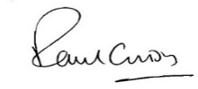
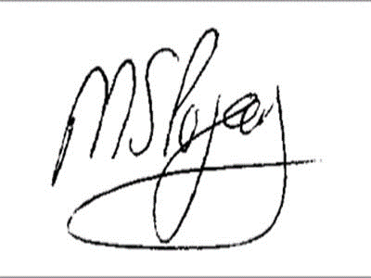

Dr Paul Cundy  GPC Co-Chair of the Joint GP IT Committee | Dr Manpreet Pujara  RCGP Co-Chair of the Joint GP IT Committee

Extension of the Flu Vaccination Programme to Care Workers
The scheme to provide seasonal flu vaccinations for frontline social care staff in England is now in operation. Information is available on the NHS England website at https://www.england.nhs.uk/flu/ with some frequently asked questions and answers set out below:

- Which staff are eligible under the extension to this programme?
Health and social care staff, employed by a registered residential care/nursing home or registered domiciliary care provider, who are directly involved in the care of vulnerable patients/clients who are at increased risk from exposure to influenza, meaning those patients/clients in a clinical risk group or aged 65 years and over.

- Where can eligible staff get their vaccination?
Most community pharmacies and many GP practices will provide the vaccinations. We recommend that staff contact their community pharmacy or GP practice to check they are providing the service, before attending. For GP practices, this has to be the member of staff’s registered practice.

- What ID should staff take to their pharmacy/GP to be vaccinated?
Eligible staff will need to take appropriate ID which shows their name and their employer such as an ID badge, letter from their employer or a recent pay slip.
.

